Device Name: Microsoft - Surface Go

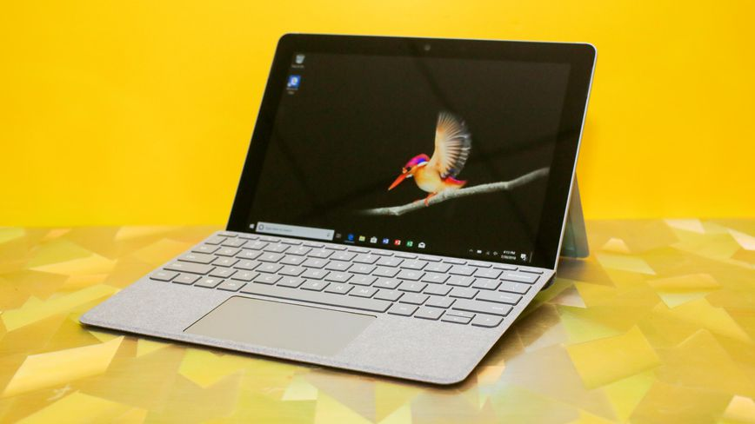

Price: $600

**SPECIFICATIONS:**

|  |  |
| --- | --- |
| Processor: | Intel Pentium Gold (1.6 GHz) |
| Memory: | 8 GB DDR3 |
| Storage: | 128 GB |
| Screen Size: | 10 |